Shell Script Exercises

- Write a shell script that will take the year as a input from the user and inform user whether it is a leap year or not. Display the output in the blinking text.(Hint: tput command)
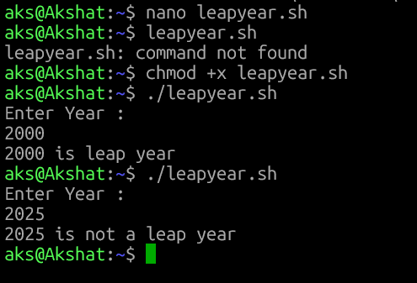
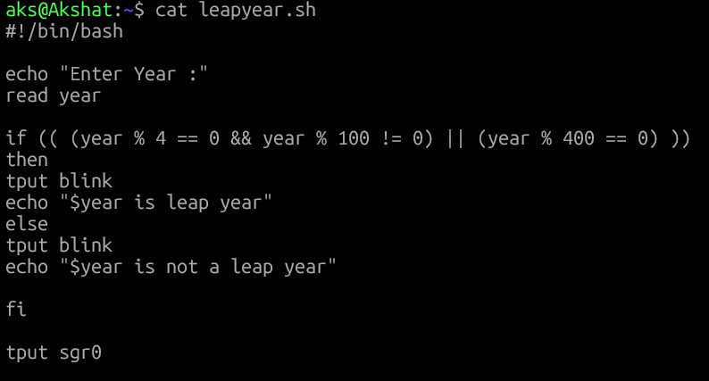

- Write a shell script that will take the name of a file from the user and check if the file is modified or not and display the message accordingly to the user. (Hint: use diff command. Check the exit status of the diff command)
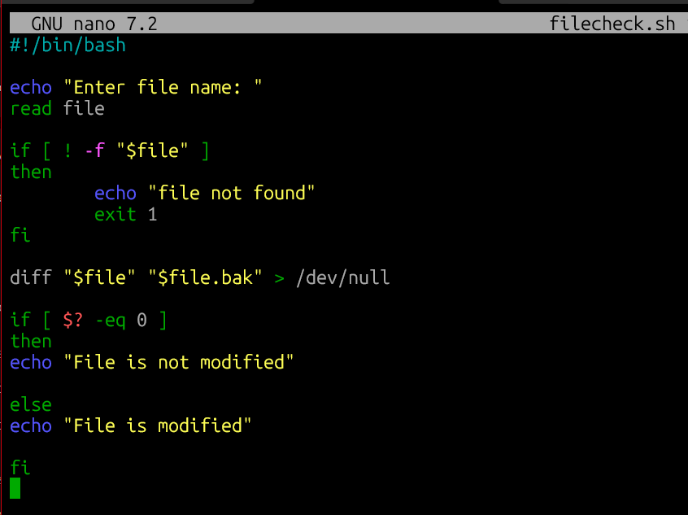
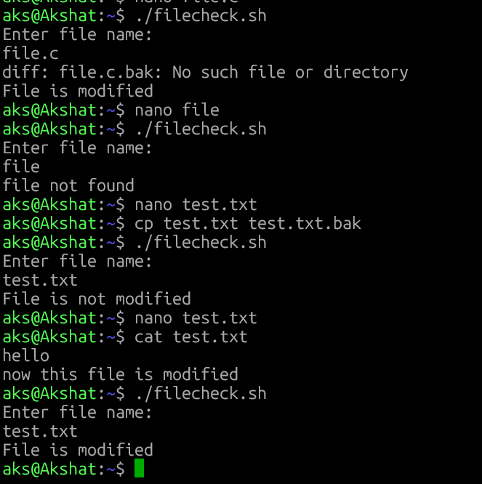

- Write a shell script to generate the Fibonacci series up to a specified number. Take a number from the user and display the Fibonacci series upto this number.
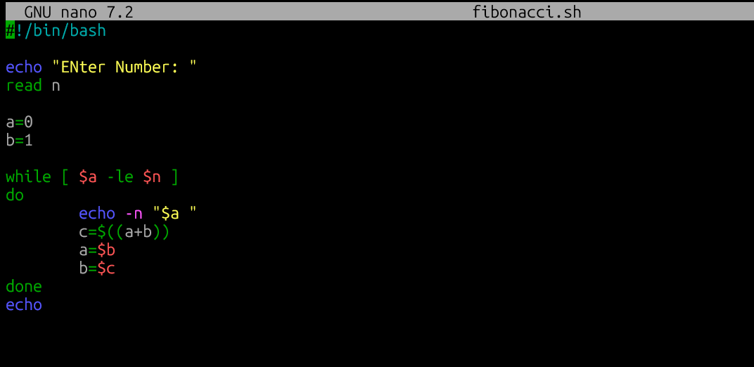
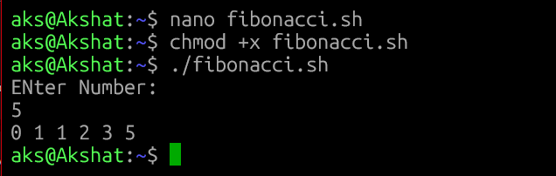

- Write a shell script. Write 4 functions each for addition, subtraction, division and multiplication of 2 numbers. Ask user to enter 2 numbers. Also ask user the operation user wants to perform and then call the respective function and display the result. Use case statement.
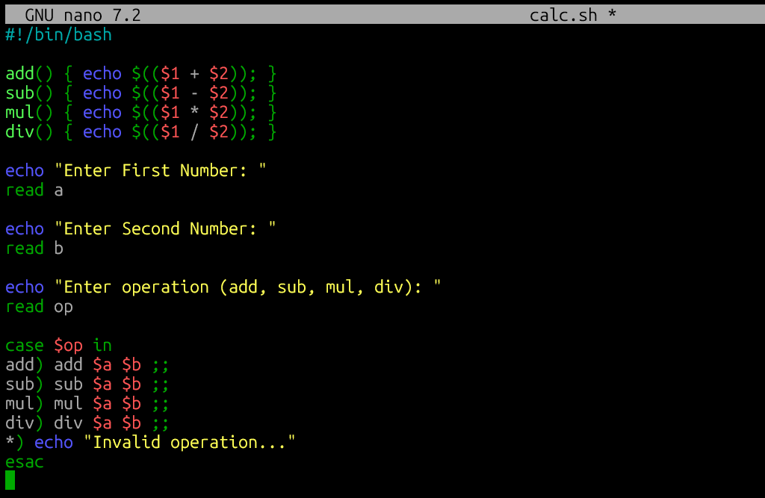
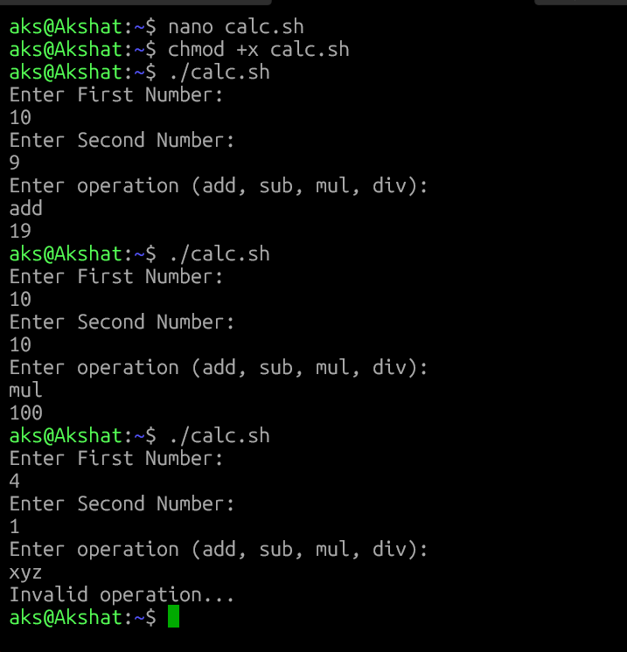

- Write the above script such that the script will not prompt user for anything. User will execute the script as shown below.

./calc.sh add 10 20
OR ./calc.sh div 10 2
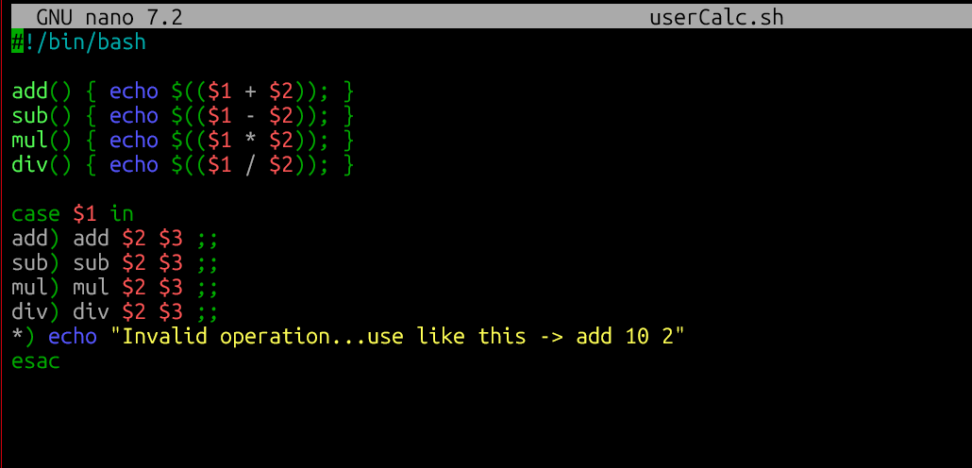

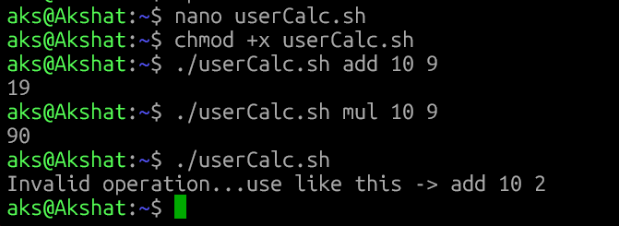
- Write the script that will take a number from the user and display whether the number is an odd or even number. Display the prompt in Red color. Display the output in Blue color and blinking text.
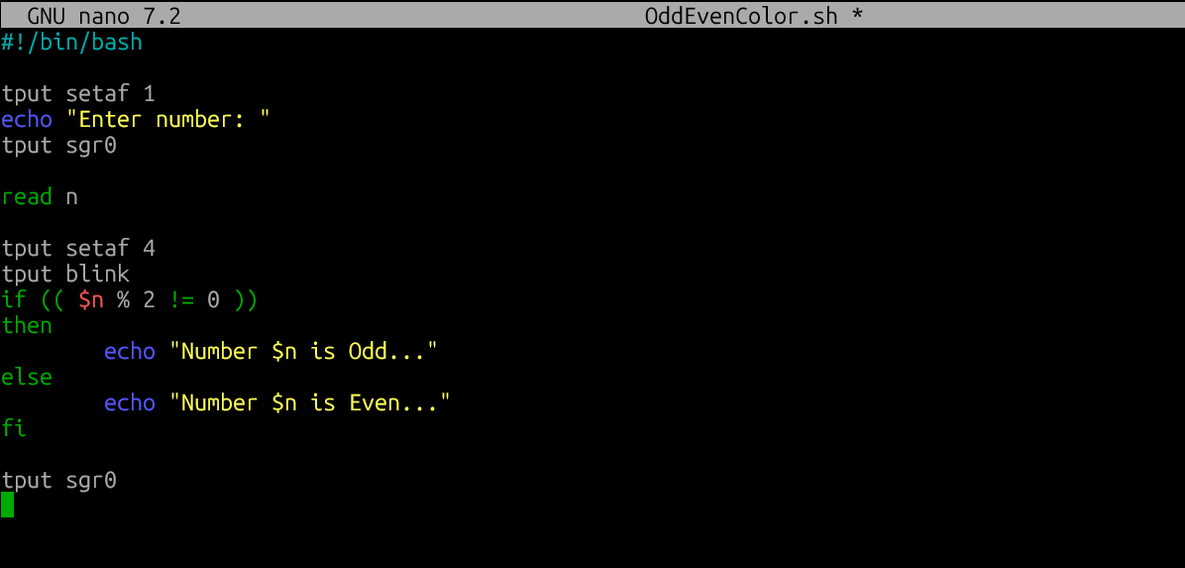
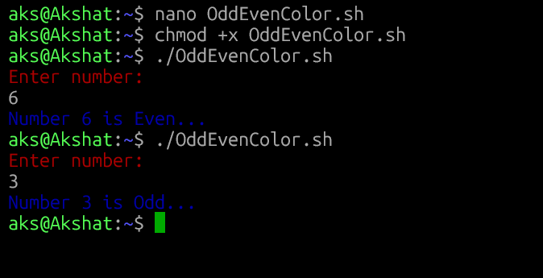

- Write a shell script that will take a number from the user and display the square and square root of the number.
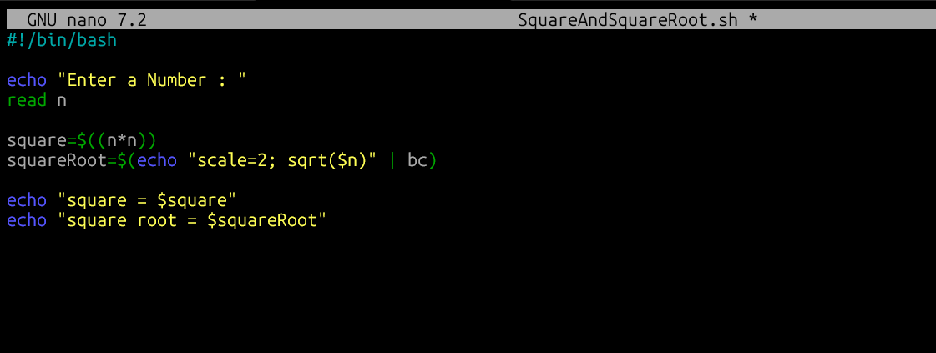
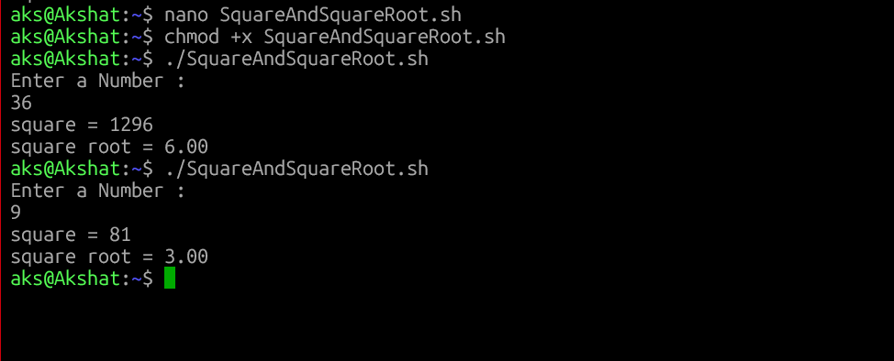

1. Write a shell script which takes a number from a user and displays if the number is even or odd. Display the result with blinking text.
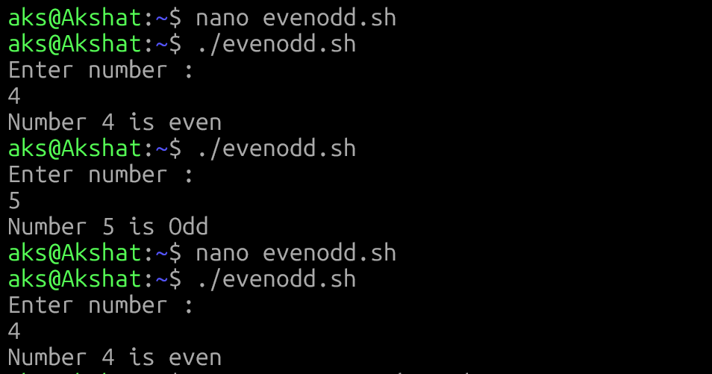
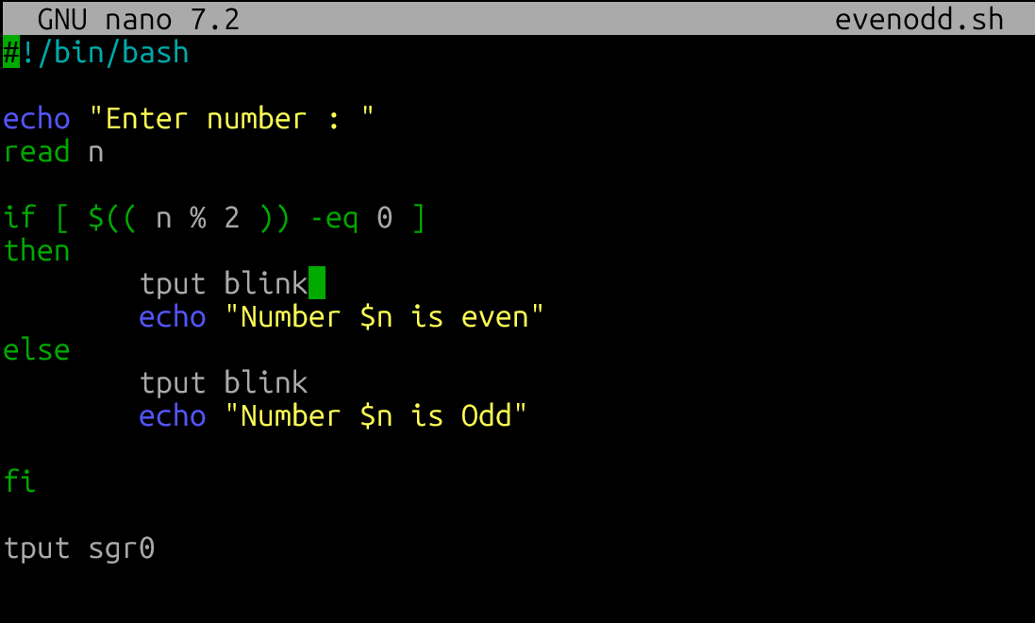

##############
2. Write a shell script which takes 2 numbers from the user and checks if number 1 is greater than number 2. Display the result in red color.
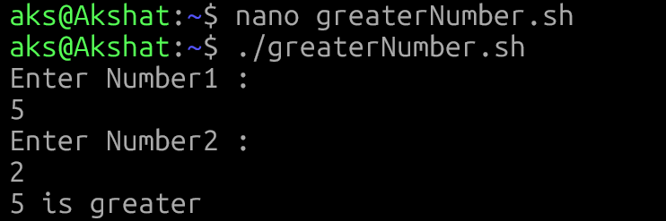
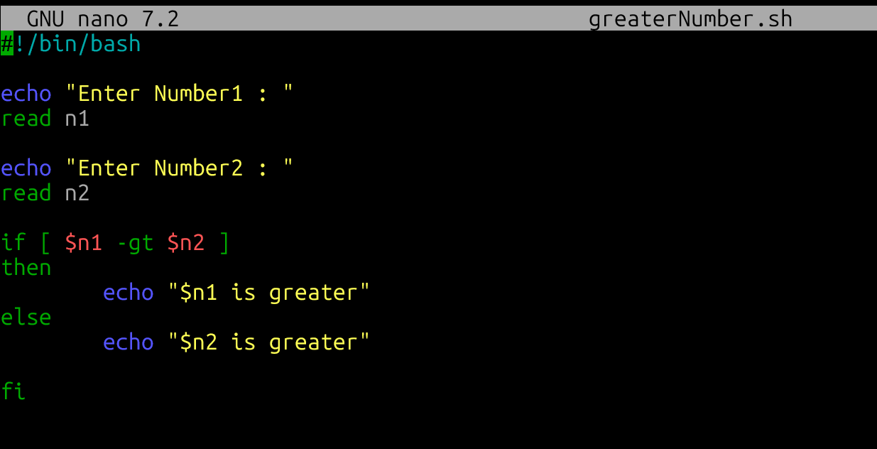

3. Write a shell scrip that will ask the user following information.
name, age, email, mobile, city. If the age of the user is above 50 then set the discount to 30% else discount should be 10%. Then store all this information in a file by name customer.txt. Each line in the file will contain a new customer info.
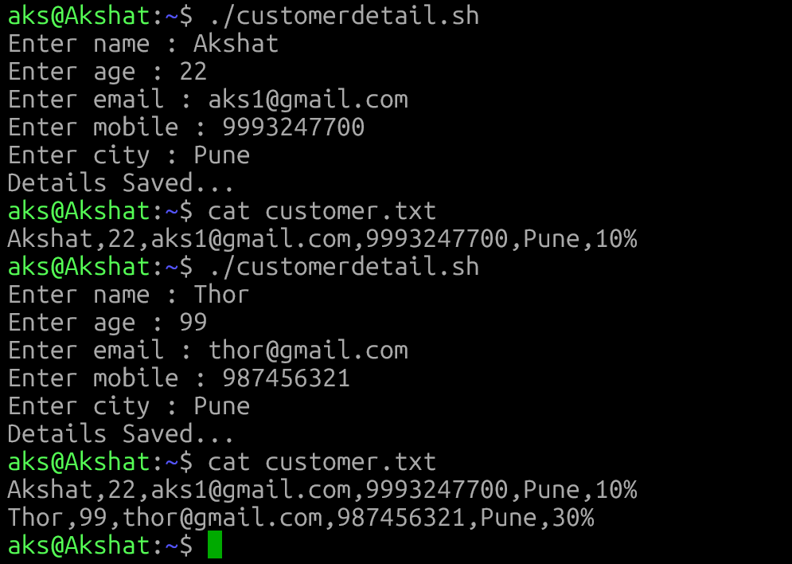
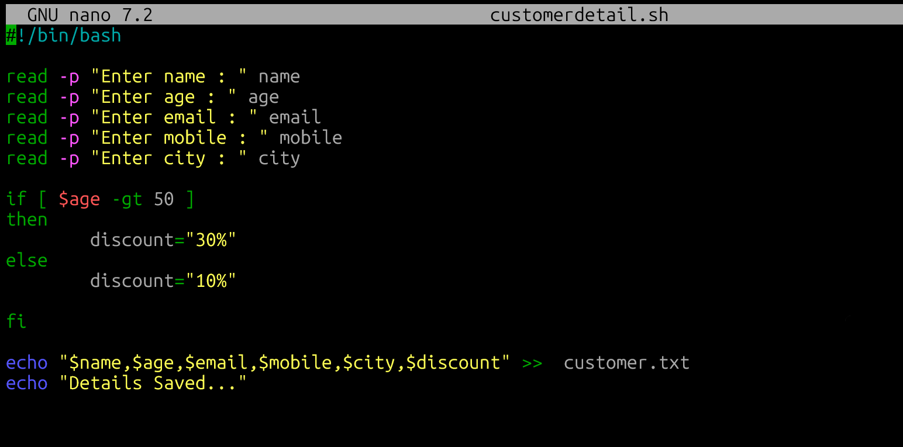

Hint:-
echo "$name,$age,$email,$mobile,$city,$discount" >> customer.txt

Modify the above script. Ask user the mobile number first. Check if the mobile number is present in the file. If the mobile number is in the file display message "Thank You!! Already Registered" else ask the details and store in the file.
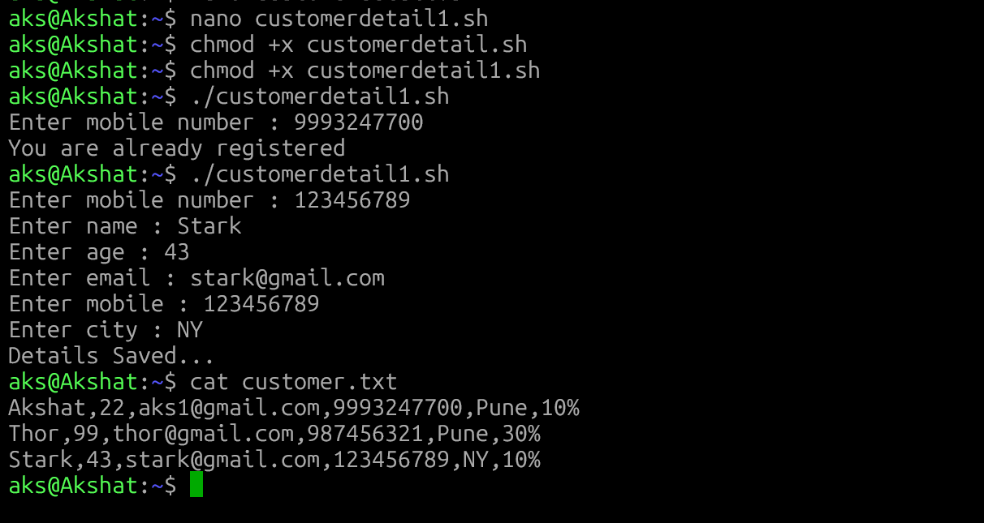
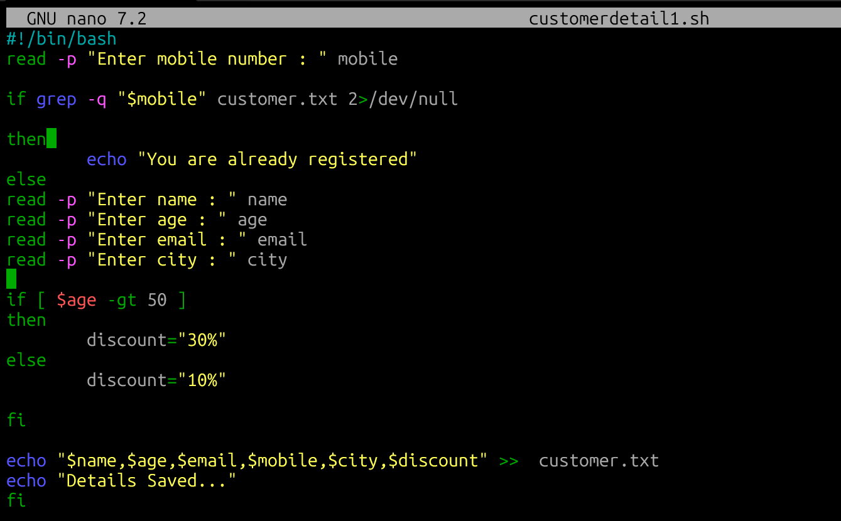

##########

4. Write a shell script using case. Ask user the country. If the user is from America display the current dollar to rupee rate. If the user is from Germany then display the current Euro to rupee rate. for all other inputs it will display message "We will get back to you!!!"
For all users display "Welcome to INDIA!!!"
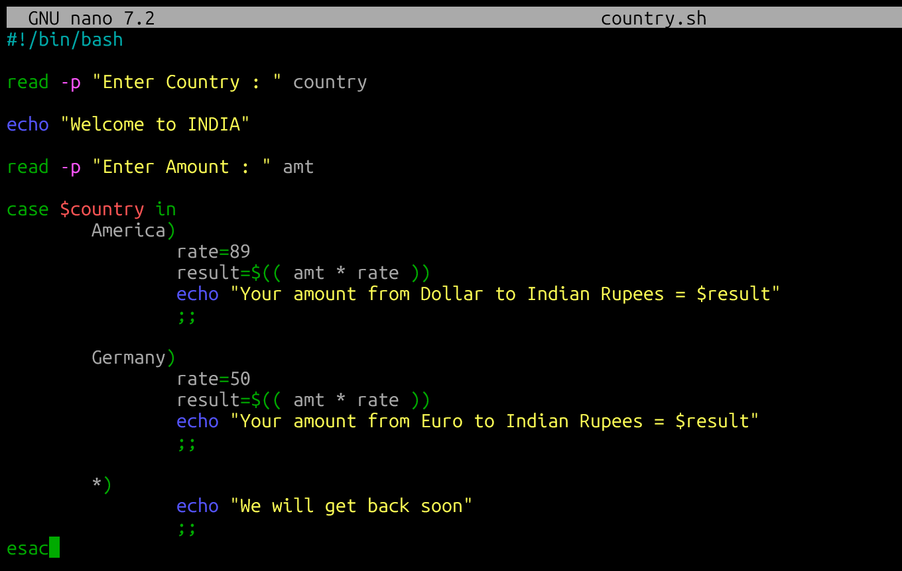
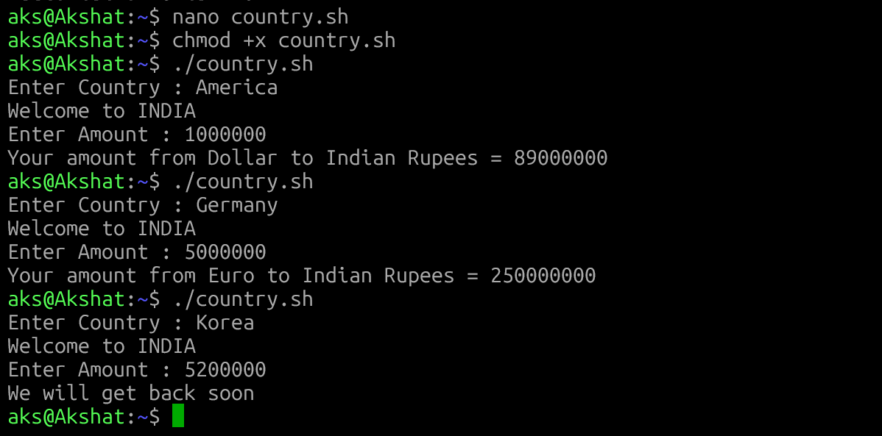

Modify above script and ask user how much currency user has? Convert it to Rupee and display.

5. Write a shell script to calculate the factorial of a number given by the user.
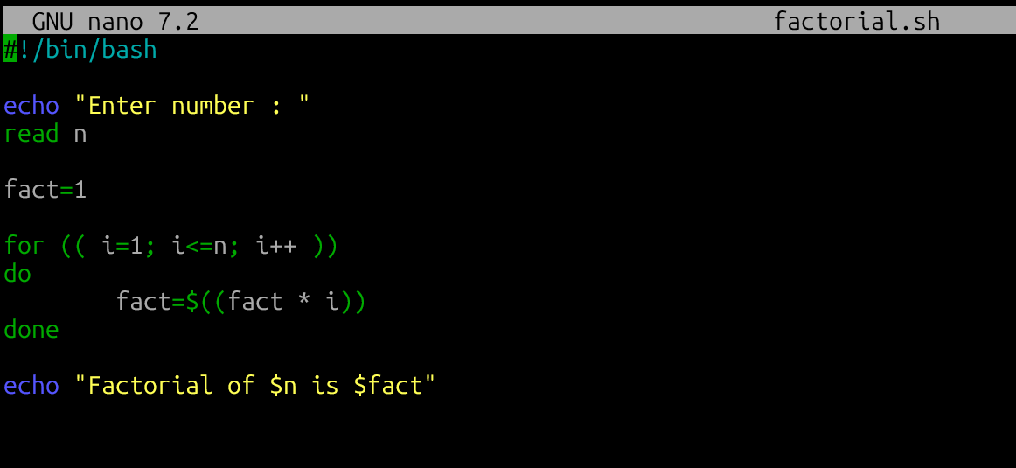
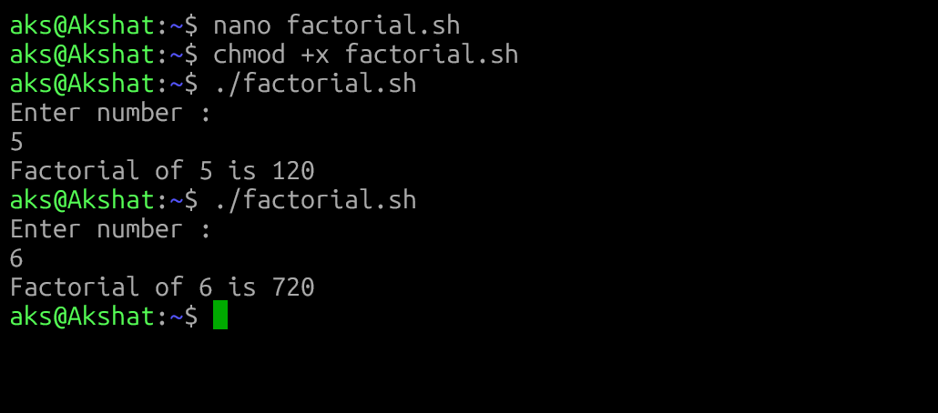
Hint: -
factorial 4 --- 4x3x2x1

6. Write a shell script using function. The script will take 2 numbers from the user and operation to perform. And display result.
